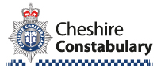

Please note that your local Officers are

Police Officer
37293 Gary Fulton
Police Community Support Officer
7149 Sharon Jones

They can be contacted in the following ways:-

gary.fulton@cheshire.police.uk
sharon.jones@cheshire.police.uk

 Bunbury and Wrenbury Police


You receive news and appeals, local crime information and crime prevention advice direct to you as an e-mail, mobile text or voice message. Find out more on the Cheshire Police website.

Please remember
For an emergency ring 999
For non-emergency ring 101or report online by logging onto www.cheshire.police.uk

