### **Spurstow Parish Council**

**Minutes of a meeting of the Council held in the Ridley Chapel at St Boniface Church, Bunbury on Thursday 24th November 2022 at 20:00.**

### Clerk: C Jones, Rose Cottage, Spurstow CW6 9TG [clerk@spurstow.org.uk](mailto:clerk@spurstow.org.uk)

|  |  |
| --- | --- |
|  |  |
| Date: | 1 X29th November 2022 |

Present:- Cllr. Hutchinson (Chair), Cllr. Finney, Cllr. Bell, Cllr. Middlemiss, Cllr. Whitehead, Cllr. Lea, Cllr. Crompton, Cllr. Jones.

In attendance, C Jones (Clerk) Cllr. Stan Davies of Cheshire East Council.

Although the Council welcomes members of the public, there were no members of the public in attendance.

Agenda - Quarterly Council Meeting

1. **Apologies for absence.** None.
2. **Declaration of interests** – Members were asked to declare any interests under the following categories: - Pecuniary interests, Outside body interests, Family, friend or close associate interests, There were none declared.
3. **Approve the minutes of last meeting** – Approved, Proposed by Cllr. Midlemiss, seconded by Cllr. Bell,
4. **Open Forum (15 minutes).** No members of the public were present
5. **Council Composition and Elections.** The Chair welcomed Cllrs. Jones, Crompton and Whitehead to the meeting and thanked them for their work on behalf of the Council already.It was noted that all the positions on the Council will come up for election in May 2023, as well as the note below from ChALC “… note that co-options occur when an election is not possible, such as for a casual vacancy that might arise between an ordinary election year and when no poll is claimed.   This then triggers a specific process and I have attached information which may be helpful.  Co-optees hold the councillor position for the length of time remaining when the vacancy occurred for example, if the term of office has 8 months to run then they will need to stand for election at the end of that term. So if you have co-opted councillors in seats that are due to end in 2023 – then these will be up for election.”
6. **Flooding in the parish.** Cllr Middlemiss reported that there was already some flooding (as of 23rd November) – he has met with Yvonne Fairclough, Ron Spacey and Mike Hiscox and noted that the fields, gardens and garden sheds were already underwater. It was decided that The Council would try to get Paul Reeves (Cheshire East’s flooding officer) to attend, with particular stress on the area between Mr Hiscock’s land and the drain near Talbarn. It is still thought that there may be a blockage under the drive of Green Butts Farm, or under the road itself. Cllr. Hutchinson will email Mr Reeves as a follow up to her discussions with him in October 2021.

Despite the recent jetting, and following some substantial rain, there are now signs of impending flooding, particularly the drain that is bubbling up on the corner, on the left of the road travelling towards Bunbury, near to the footpath with the kissing gate, at the end of Springfield’s garden. Ms Fairclough and Cllr, Finney have both contacted United Utilities, who visited last 23rd November, and who said that the issue was not with United Utilities, but a Cheshire east Council Highways issue.

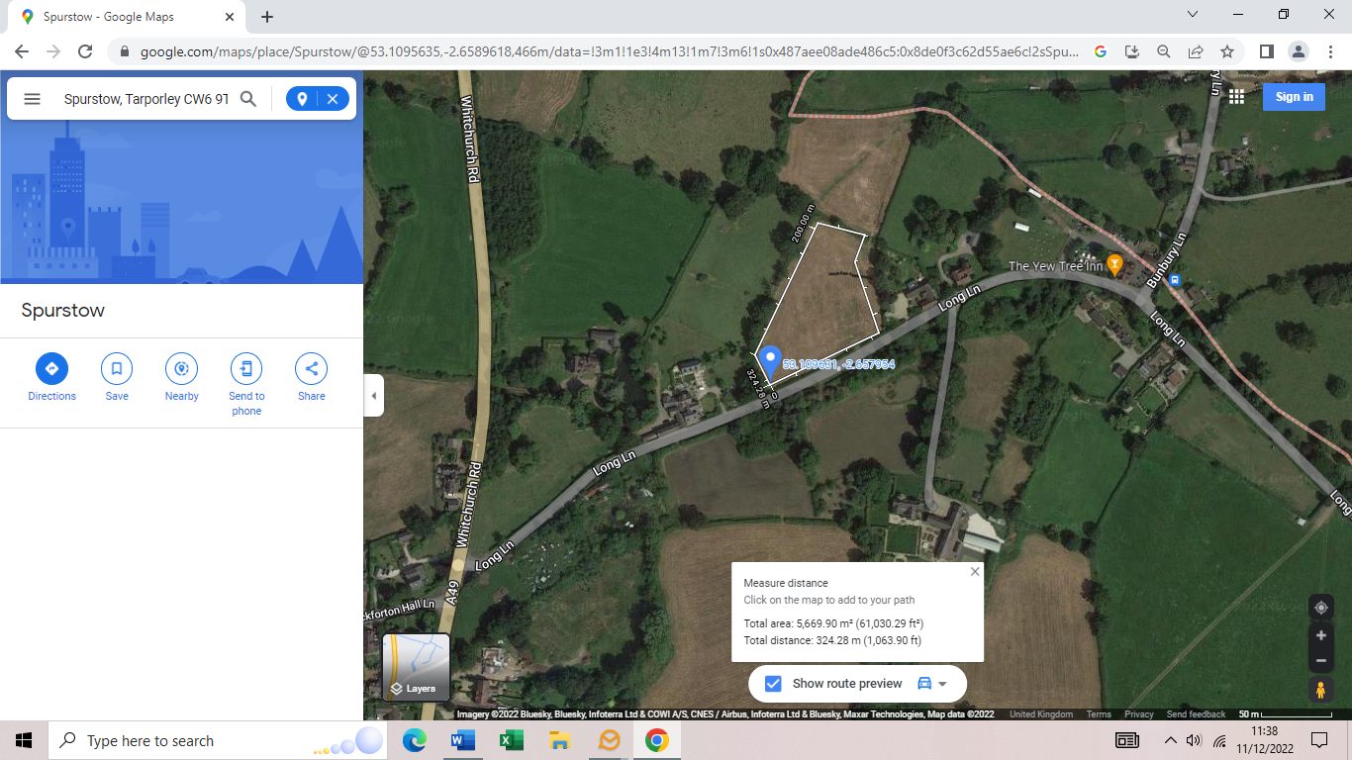Cllr. Jones suggested that the Council attempt to contact the owner of the field to the North side of Long Lane between Springfield Lodge and Talbarn, perhaps Alan and Michelle Harding from Bunbury Lane, Cllr. Middlemiss and Cllr. Finney will try to speak to the landowner.

To agree to continue to record whether there has been any flooding so we can act if any further flooding occurs (via the Clerk.)

1. The caravan that is at the junction of Badcocks Lane and Long Lane was discussed. The Clerk has not been able to find out who the land belongs to. The meeting considered whether this area can be protected in some way, and it was agreed that the Chair and/or Clerk would try to meet with Mr and Mrs Barlow of Spurstow Hall to discuss the matter. The Clerk is to try to get copies of the deeds of Alan Wright’s property and those of Spurstow Hall, to see whether they establish the ownership of the plot of land.
2. **Climate Emergency.**  Councillors brought various ideas about how the Council can contribute to reducing the effect of the Climate Emergency.
   1. Cllr. Hutchinson would like to work a small area of community woodland in the parish, for the benefit of the electors and others and suggested we could request porous material be used to lay drives to reduce the rapid run-off of rain which can exacerbate flooding.
   2. Cllrs. Jones and Bell suggested that by default for Spurstow Parish Council should comment on any new planning requests to encourage any new building to include at least i) permeable drives and paths ii) renewable energy provisions iii) wildlife-friendly facilities.
   3. Cllr. Bell suggested that we write to the Chief Executives of Cheshire East Council, Cheshire West and Chester Council. Wirral and Shropshire Councils as well as Sarah Pochin and Edward Timpson MP to ask about whether it is possible to allow reciprocity between local councils allowing residents to use the recycling centre that is nearest to their homes, irrespective of which Council operates that centre. Cllr. Bell and the Clerk are to compose a suitable letter emphasising environmental considerations as well as reduction in fly-tipping etc. when travelling to a tip is made easier.
   4. Cllr, Whitehead asked that the Council promote led lighting, especially in the context of outbuildings.
   5. Cllr. Finney suggested that the Council get street lights switched off between 23:30 and 06:00, the Clerk is to investigate.
   6. Cllr. Jones. Suggested that the Council write and publish guidance that advises how to best to use recycling facilities, to increase the amount of waste produced in the parish that is recycled.
   7. Cllr. Middlemiss suggested that the Council sponsor a skip for a “metal amnesty”, perhaps in the Yew Tree car park to give parishioners the opportunity to easily recycle larger items, Cllr. Middlemiss is to talk to a local metal recycling company.
   8. Cllr Crompton – Supported all the above, but suggested that electronic communications would be a more eco-friendly way to disseminate the ideas above, and agreed to manage the first incarnation of the Council’s Social Media Presence.

The chair was delighted by the scope and quality of the suggestions, we will continue to pursue these ideas and any others people have over the next few meetings to allow them to bear fruit.

1. **Planning applications, current, and outstanding.**

Application 22/4040N “Land North of Hillview”, a request for discharge of conditions was discussed. Cllr. Hutchinson and the Clerk have visited the site, which is broadly in line with the plans agreed with Cheshire East Council, however, the garage does appear to have been subtly re-designed to allow for easy conversion to a secondary dwelling, and would perhaps be a small garage. The house does appear to be about 2m further back from the road than was implied on the plans. It was agreed that the Council would take no further action, other than to ask Cheshire East Council to ensure that the electric vehicle charger was as specified**.**

Cllr. Finney said that planning permission has been sought for up to 25 houses in Bunbury behind the Yew Tree – Cllr Finney will keep abreast of developments at Bunbury Parish Council. It was agreed that the Clerk will write to Cheshire East to re-iterate the Council’s objections to previous applications which have already been rejected.

1. **Highways Issues and Alternative Ways to Manage Speed.**

The Speed Indicating Device had been installed on the A49 near Panama Hatty’s (both ways) and on Long Lane between the A49 and the Yew Tree (both ways) The Clerk provided a summary of the data before the meeting. There was a useful discussion, and the Council were pleased to note that the Speed Indicating Device, particularly on Long Lane seems to have raised awareness of actual speeds on Long Lane, and the feeling is that speeds have decreased whilst the SID was there. SID data shows that the great majority of cars are travelling under the 40 miles per hour speed limit on the A49. Cllr. Whitehead felt that by this point people have slowed down, but that they are travelling much faster going past the exit of Badcocks Lane onto the A49. The safety of traffic leaving Badcock lane onto the A49 and the situation concerning the listed building presently cordoned off were discussed.  It was agreed to put the SID near the exit from Badcocks Lane, exact position to be discussed with Cllr. Whitehead. He has asked Cheshire East Council several times before to consider a one-way system around the park home development.

The chair thanked the Clerk for his diligence in siting and moving the SID and providing useful information

1. **Vyrnwy Aqueduct Modernisation Program (VAMP).** The Council were very pleased with UU’s attitude and felt encouraged by UU’s attitude and openness, and noted the contents of appendix 1 below containing notes of the meeting of 2nd November 2022 at the Lockgate Café about the VAMP.
2. **Hedgehog Highway** – After reviewing the appendix below for details of an initiative to help hedgehogs in the area. The Clerk had written to Peckforton, Beeston and Haughton Parishes to see if there would be any interest in buying some hedgehog surrounds at cost price in their Parishes – Haughton Parish Meeting have expressed an interest in about 17 It was agreed to buy a pack of 50. Cllr. Jones suggested distributing a large proportion to a local interest group, after selling some to Spurstow Residents.
3. **Correspondence.** The Clerk will reply to a “Know your customer” request from Barclays Bank.
4. **Finance Update and payments due:**

The only payment since the last meeting has been for £ 60.00 to Bunbury Parochial Church Council for room rent.

Date and time of next meeting:-

23rd March 2022 at 20:00, the meeting is expected to be at St Boniface,Bunbury

There being no other business the meeting closed at 22:10

## **Appendix 1 - Vyrnwy Aqueduct Maintenance Program Update**

Dear Mike/ John/ Spurstow Parish Council,

Thank you for your time on 02/11/22 to discuss the United Utilities Vyrnwy Aqueduct Modernisation project, we hope that the meeting was useful in providing an update on our progress to date and progress on the last meeting’s actions, in addition to providing further information on our programme and schedule of upcoming works.

Before I jump into the meeting minutes, you may recall at the meeting we discussed that the project is planning to hold public drop-in sessions for local residents in the new year and we are now looking at possible venues. We are therefore enquiring about a suitable venue/ village hall in Peckforton / Beeston village for our drop-in sessions next year. If you are able to provide any availability on the 21st and 23rd of February 2pm-7pm and what the capacity of the village hall may be that would be great.

Apologies for the delay in getting the meeting minutes out, I have been out of office for a large proportion of this week. Nevertheless, please find the meeting minutes below, along with an overarching summary of what was discussed.

**Summary;**

•         *Review of last meeting notes and provided updated on specific actions.*

•         *Introduced scheme to Spurstow PC Representative (Les Catherall) on behalf of Spurstow PC.*

•         *Introduce the Parish councils to the contractor (Avove).*

***Last meeting update and new actions:***

o   *UU Provided an update on project, construction techniques and potential impacts + Confirmed the programme with the Parish Councils for CA03:*

▪  *Advanced works – January to February 2023*

▪  *Enabling works (Beeston) from late-November to mid-December (Current programme: 29/11/22 – 19/12/22)*

▪  *Main works:*

•         *Jetting : Summer 2023*

•         *Lining (1): Winter 2023*

•         *Lining (2) Winter 2024*

o   *UU Provide update on PROW and highways discussions at Moss Lane + Main Compound:*

▪  *UU provided update on PROW discussions with Cheshire West*

▪  *ACTION: UU to provide update on Highways impacts along A49 (main compound) with any speed restriction measures following on from Highways engagement to discuss – To discuss next meeting.*

o   *Update functionality on virtual exhibition: UU confirmed progress on providing update functionality to the virtual exhibition with plans to have drafts on what this will look/feel like later 2022, to go live in Feb 2023 ahead of main construction to provide required updates for Area 03.*

o   *UU to provide reinstatement spec and photos of reinstatement: UU confirmed with Parish councils that this is being progressed and will update PC accordingly.*

o   *UU to update local communities with information about works:*

▪  *UU current plans to hold Public drop-in sessions in early 2023 ahead of main construction works with local residents. –* ***As per above, UU are reviewing possible venues in Peckforton/ Beeston.***

▪  *Ongoing and tailored communications to Parish council utilising their distribution lists to push out key messages*

▪  *UU to produce ‘newsletters’ to go out to parish at a frequency agreed during main construction works.*

o   *ACTION: UU confirmed further updates to the virtual exhibition website to include changes that have been made as a result of planning + also provide updated numbers of vehicles associated to each working area.*

o   *ACTION: UU to Inform Parish Councils on the proposed traffic routes ahead of any works starting*

▪  *Parish Council help to keep residents informed via distribution channels*

▪  *UU to arrange for comms and any necessary site signage to capture road users*

o   *ACTION: UU to Share plans of Public Right of Way closure and diversion when confirmed at Moss Lane.*

If I have missed anything, please do let me know. I look forward to discussing these points at out next meeting (To be agreed) and as ever, we will continue to keep the parish council up to date as our project progresses.

Kind Regards,

Harry Caton

|  |  |
| --- | --- |
|  | **Harry Caton**  Assistant Project Coordinator  Network and Capital Delivery  unitedutilities.com |

**Appendix 2 – Hedgehog Highway**

A Hedgehog Highway is a 5-inch gap in a fence or wall allowing access for Hedgehogs. Other names include 'Hedgehog Door', 'Hedgehog Hole' and 'Hedgehog Tunnel'

These gaps are essential in the battle to prevent the extinction of our endangered spiky friends.

The Hedgehog Highway allows hedgehogs to:

   * Forage for food

   * Meet mates to breed

   * Access nesting sites

**Why should I get a Hedgehog Highway Surround?**

1. Hedgehog Highway Signs look super cute!

2.  They raise awareness to hedgehogs' struggle for survival

3. They create a talking point, encouraging others to create a highway of their own and take part in the project

4. Money from the sale of every Hedgehog Sign is donated to help the rescue of sick and injured hedgehogs

#### **Retailers, Councils, Community Groups - Please #BuyABox**With Hedgehog numbers in severe decline and Hedgehog awareness on the rise, there has never been a better time to invest in Hedgehog conservation products.   If you would like to be a stockist and buy a box, then please click on the link above.

#### Your box will include:

* 50 Hedgehog Highway surrounds & 50 information leaflets
* 1 Display box
* 1 Window sticker to show that you are part of the project and are doing your bit to help the hogs.
* 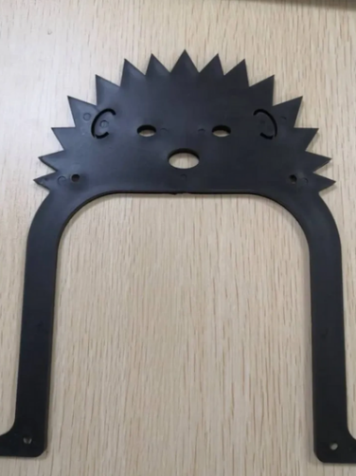

Cost is £ 150.00